CHAPTER 18: METAFILES

Metafiles vs. Bitmaps: Metafiles are to vector graphics as bitmaps are to raster graphics. Metafiles are constructed by humans, while bitmaps generally originate from real-world images. Metafiles consist of a series of binary records that correspond to graphics function calls, while bitmaps are a collection of pixels.

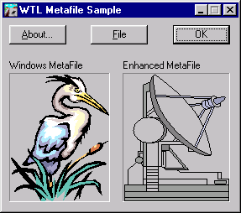

Creating and Editing: "Paint" programs create bitmaps, while "draw" programs create metafiles. In a well-designed drawing program, you can easily grab and move individual graphical objects because they are stored as separate records. In a paint program, you are generally restricted to moving or removing rectangular chunks of the bitmap.

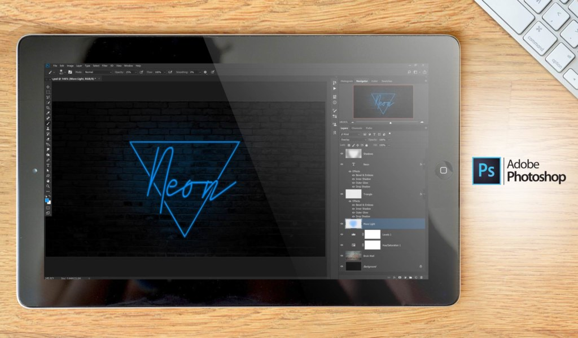

Scaling: Because metafiles describe an image in terms of graphical drawing commands, the metafile image can be scaled without loss of resolution. Bitmaps, on the other hand, cannot be scaled without losing resolution.

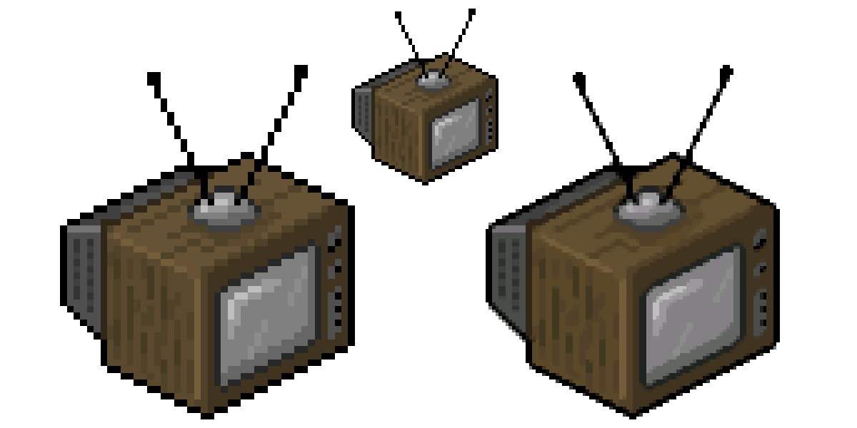

Converting: A metafile can be converted to a bitmap, but with some loss of information. Converting bitmaps to metafiles is much more difficult and usually requires a lot of processing power.

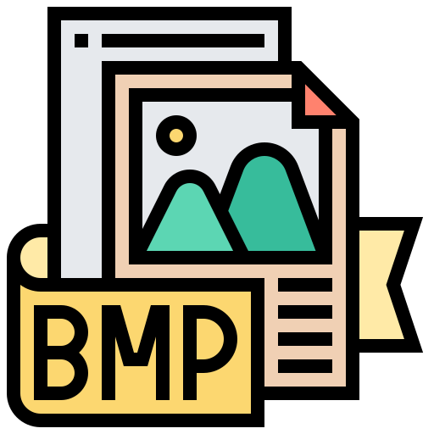 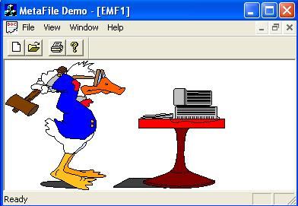

Uses: Metafiles are most often used for sharing pictures among programs through the clipboard, although they can also exist on disk as clip art. Because metafiles take up much less space and are more device independent than bitmaps, they are generally the preferred format for sharing and storing images.

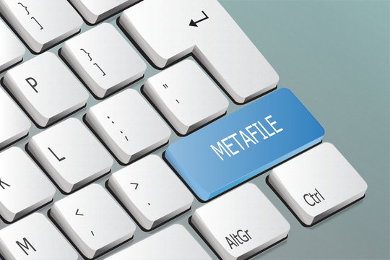

Windows Metafile Formats: Microsoft Windows supports two metafile formats: the original metafile format, which has been supported since Windows 1.0, and the enhanced metafile format, which was developed for the 32-bit versions of Windows. The enhanced metafile format has several improvements over the old metafile format and should be used whenever possible.

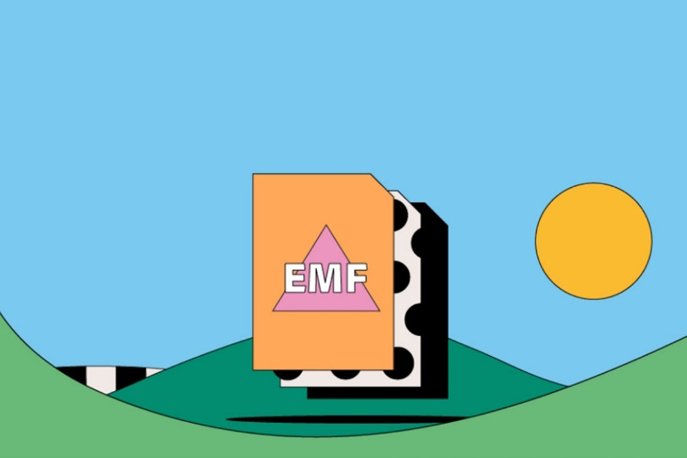

UNDERSTANDING THE OLD METAFILE FORMAT: A COMPREHENSIVE GUIDE

Metafiles: Blueprints for Vector Graphics

In the realm of Windows graphics, metafiles offer a unique approach to image creation and manipulation. Unlike bitmaps, which store pixel-by-pixel representations of images, metafiles act as blueprints, storing a series of drawing commands that can be replayed to recreate the image on various devices. This mechanism offers several advantages, including:

* Device Independence: Metafiles can be rendered consistently across different displays and printers, ensuring graphical fidelity.
* Compactness: Metafiles often require less storage space compared to bitmaps, especially for images with simple shapes and lines.
* Scalability: Metafiles can be scaled without loss of quality, as the drawing commands are recalculated to maintain visual integrity.

Creating and Using Memory Metafiles

Here's a step-by-step guide to working with memory metafiles in Windows:

Metafile Device Context (MDC) Creation:

Initiate the process by calling CreateMetaFile(NULL). This function allocates memory for a metafile and returns a handle to an MDC, which serves as a virtual canvas for your drawing commands.



Drawing on the MDC:

Utilize standard GDI drawing functions like LineTo, Rectangle, TextOut, and others to construct your image on the MDC. However, these calls don't directly render on a physical device; instead, they are meticulously recorded as instructions within the metafile.

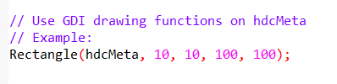

Closing the MDC:

Once you've completed your drawing, call CloseMetaFile to finalize the metafile and receive a handle to the encapsulated graphical data.



Playing the Metafile: Rendering the Image

To display the image stored within a metafile, follow these steps:

* Obtain a Real Device Context: Acquire a device context (DC) representing the physical device where you intend to render the image, such as a window's DC.
* Invoke PlayMetaFile: Pass the metafile handle and the real DC to the PlayMetaFile function. This initiates the execution of the recorded GDI commands, resulting in the image being meticulously drawn on the specified device.

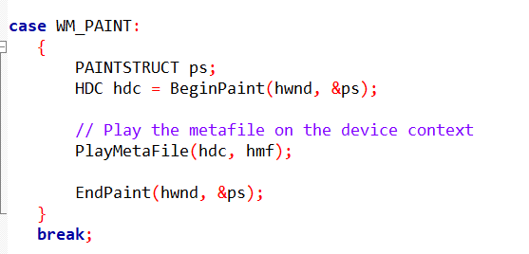

Saving as Disk Metafile:

The CreateMetaFile function takes a single argument, which can be either NULL or a filename. If it's NULL, the metafile is stored in memory. If a filename is provided (commonly with the .WMF extension), the metafile is saved as a disk file.



Key Points to Remember:

Windows gracefully handles file operations for disk-based metafiles, alleviating you from file I/O concerns.

While the old metafile format remains functional, the newer Enhanced Metafile (EMF) format is generally recommended due to its advancements in functionality and compatibility.

METAFILE.C PROGRAM

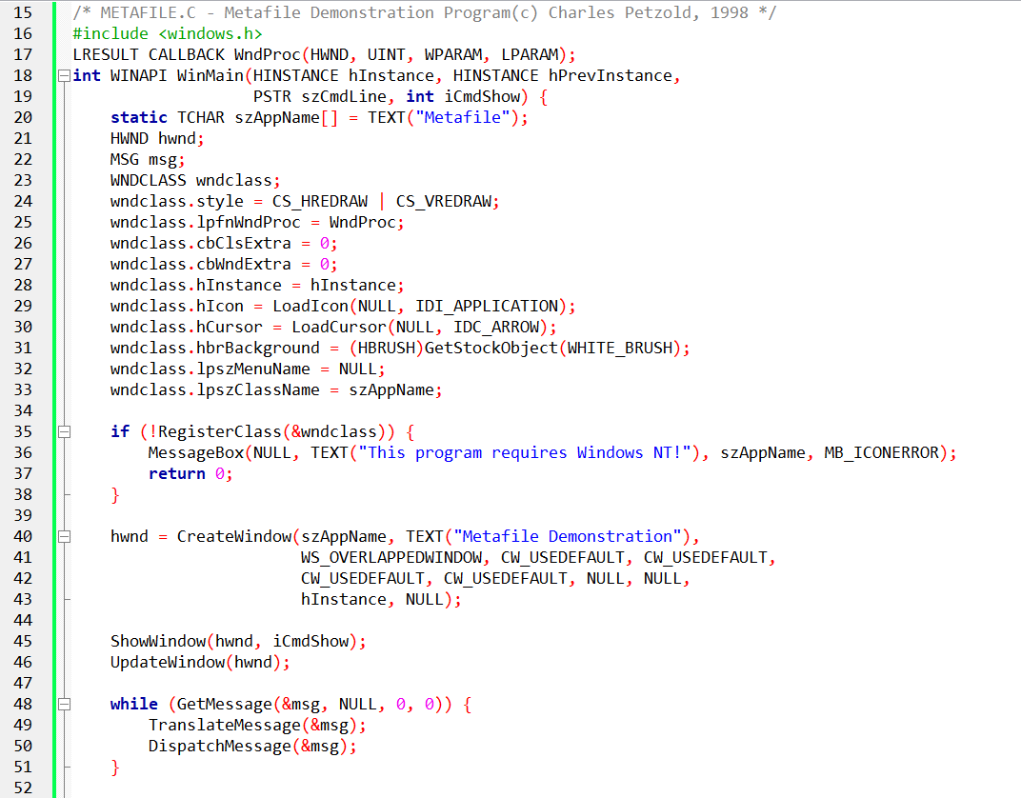 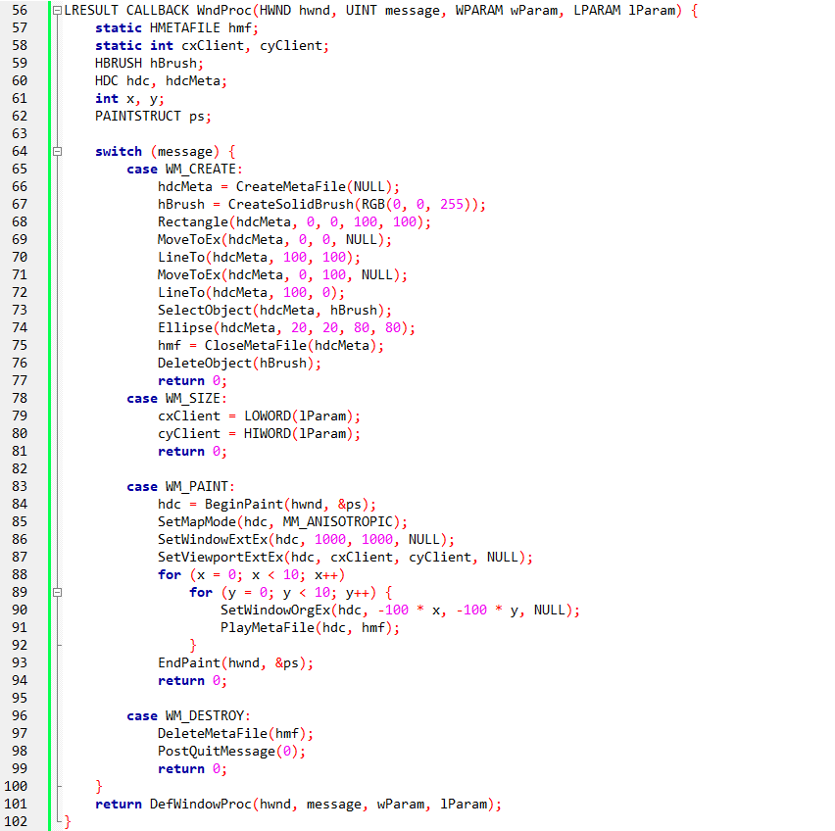

Metafile Creation:

The program begins by creating a metafile, which functions like a recording device for graphics commands. It's analogous to recording a song instead of playing individual notes each time.

This metafile is stored in memory, and its handle is kept for later use.

Drawing on the Metafile:

During the WM_CREATE message, the program draws shapes onto the metafile. It creates a blue brush, draws a rectangle, two diagonal lines forming an X, then uses the blue brush to fill an ellipse within the rectangle.

These drawing commands are recorded within the metafile, not directly rendered onto the screen.

Playing the Metafile:

The WM_PAINT message triggers the actual rendering of the metafile's contents.

The program obtains the window's device context (DC), which acts as a canvas for drawing.

It sets up an anisotropic mapping mode, allowing for flexible scaling of the image.

It then enters a loop, iterating 100 times to create a tiled effect.

In each iteration, it shifts the viewport origin within the logical coordinate system.

It then plays the metafile onto the device context, effectively drawing the recorded shapes multiple times in a grid-like pattern.

Metafile Handling:

After the drawing is complete, the metafile is closed, finalizing its contents.

During the WM_DESTROY message, the metafile is deleted to release its resources.

Key Points:

* Metafiles offer a way to store and replay graphics commands, providing flexibility in rendering images.
* They can be stored in memory or on disk.
* The program demonstrates a basic usage of metafiles, creating one in memory and replaying it multiple times to create a tiled pattern.
* Old Metafile Format: The program uses the old metafile format (WMF). While functional, the newer Enhanced Metafile (EMF) format offers advantages and is generally recommended.
* Anisotropic Mapping Mode: This mode allows flexible scaling, but requires careful management to ensure consistent results across different window sizes and resolutions.
* Code Structure: The code follows standard WinAPI window procedure patterns, making it approachable for those familiar with WinAPI development.

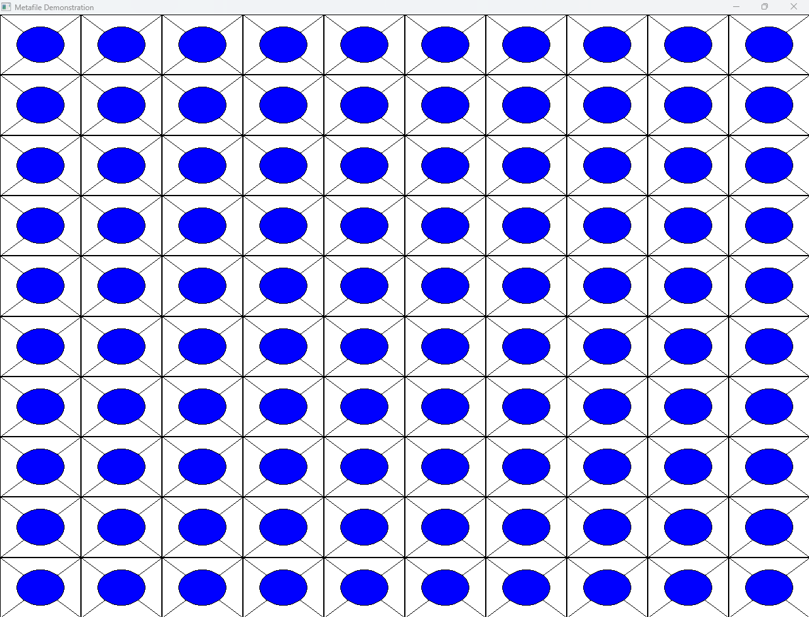

A program, referred to as "METAFILE," to store metafiles on disk rather than in memory. This approach is particularly advantageous for handling large metafiles due to its reduced memory footprint. However, it comes with the trade-off of requiring disk access each time the metafile is played.

To implement the transition from an in-memory metafile to a disk-based one, the key modification involves replacing the NULL argument in the CreateMetaFile call with a filename during the WM_CREATE processing.

Subsequently, when the WM_CREATE message concludes, the program deletes the metafile handle using DeleteMetaFile. Importantly, this deletion only affects the handle, leaving the actual disk file intact.

During the processing of the WM_PAINT message, the program retrieves a metafile handle to the existing disk file using the GetMetaFile function.

This handle can then be used to play the metafile as before. Upon completion of the WM_PAINT message, the metafile handle is deleted using DeleteMetaFile.

When handling the WM_DESTROY message, the program doesn't need to delete the metafile handle explicitly since it was already deleted at the end of both WM_CREATE and WM_PAINT messages.

However, it is crucial to delete the disk file associated with the metafile using DeleteFile(szFileName) unless there is a specific intention to retain the file.

To provide an alternative approach, the notes suggest the possibility of treating a metafile as a programmer-defined resource.

In such a scenario, the metafile can be loaded as a data block, and a metafile handle can be created using SetMetaFileBitsEx(iSize, pData).

This function allows the program to define a metafile using a block of data.

A corresponding function, GetMetaFileBitsEx, is available to copy the contents of a metafile to a block of memory.

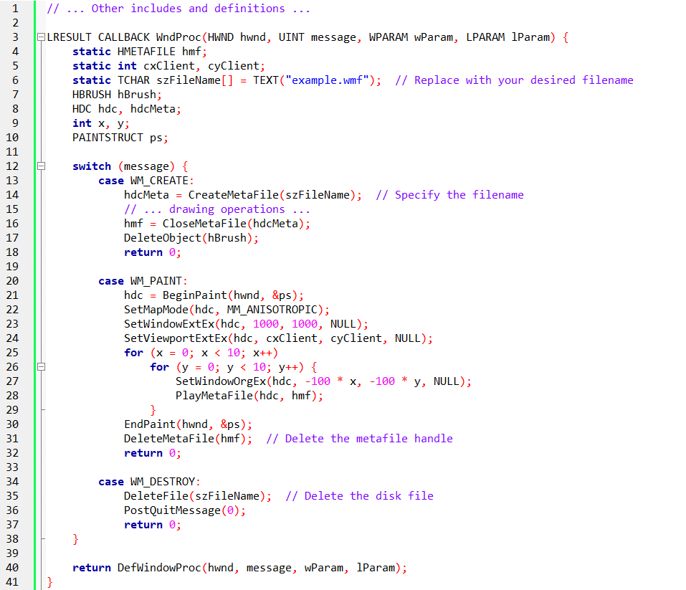

In this modified version, the filename "example.wmf" is used for illustration purposes. Ensure that the filename aligns with your application's requirements. The DeleteFile function is called during WM_DESTROY to remove the disk file associated with the metafile, providing a clean and resource-efficient approach.

Challenges with Old Metafiles:

Size Determination: Determining the rendered size of an old metafile from its handle alone is challenging, often requiring internal metafile inspection.

Clipboard Flexibility Limitations: Directly placing metafile handles on the clipboard restricts scaling and mapping control for recipient programs.

The METAFILEPICT Structure:

Purpose: Bridges the gap between old metafiles and clipboard flexibility.

Fields:

* mm: The metafile's intended mapping mode (e.g., MM_ISOTROPIC, MM_ANISOTROPIC).
* xExt: The width of the metafile image in logical units.
* yExt: The height of the metafile image in logical units.
* hMF: The handle to the actual metafile.

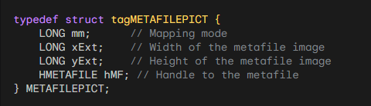

Declare a variable, fill its fields and then use it for clipboard operations or other purposes.

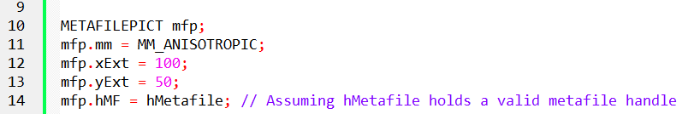

Clipboard Interaction:

*Copying to Clipboard:*

* Create a METAFILEPICT structure.
* Set the mapping mode, width, and height based on metafile properties.
* Store the metafile handle within the structure.
* Place the METAFILEPICT structure on the clipboard.

*Pasting from Clipboard:*

* Retrieve the METAFILEPICT structure from the clipboard.
* Access the metafile handle, mapping mode, width, and height.
* Adjust viewport extents and mapping mode as needed before playback.
* Play the metafile using PlayMetaFile.

Benefits:

Size Information: Provides recipient programs with metafile dimensions for scaling and layout decisions.

Mapping Mode Flexibility: Allows recipient programs to control scaling and coordinate mapping for optimal rendering.

Enhanced Clipboard Compatibility: Ensures seamless metafile exchange across different applications.

Key Considerations:

Enhanced Metafiles (EMF): Modern applications often favor EMFs for expanded features and compatibility.

Performance: Consider alternative clipboard formats (e.g., bitmaps) for large metafiles or performance-critical scenarios.

Compatibility: Be mindful of potential compatibility issues when working with older metafile formats and clipboard operations.

UNDERSTANDING MAPPING MODES AND VIEWPORTS:

Mapping Modes: Define how logical coordinates (used in drawing functions) map to device coordinates (pixels on screen).

Viewport: The rectangular region on a device context where images are displayed.

Window Ext and Viewport Ext: Control the mapping between logical and device coordinates.

METAFILEPICT's Role in Metafile Exchange:

Bridging the Gap: Acts as a container for metafile handles and essential information, facilitating seamless clipboard exchange.

Structure: Contains fields for mapping mode (mm), image dimensions (xExt, yExt), and the metafile handle itself (hMF).

Interpreting xExt and yExt:

Non-Isotropic/Anisotropic Modes: Directly indicate image size in units of the specified mapping mode.

Isotropic/Anisotropic Modes: Serve as guides for recipient programs to set appropriate viewport extents, ensuring proper scaling and aspect ratio preservation.

Recommendations for Metafile Creation:

Favor Isotropic/Anisotropic Modes: Grant recipient programs greater flexibility in adjusting scaling and mapping.

Set Explanatory xExt and yExt Values: Provide informative hints for viewport adjustments.

Avoid Internal SetViewportExtEx Calls: Ensure compatibility and adaptability for recipient programs.

Recipient Program Responsibilities:

Read METAFILEPICT Fields: Extract mapping mode, dimensions, and handle.

Set Mapping Mode and Viewport Extents: Based on display surface and desired rendering behavior.

Play Metafile: Using PlayMetaFile, respecting the communicated mapping and sizing information.

Additional Considerations:

Window Extent: Always stored within metafiles using Isotropic/Anisotropic modes, governing drawing coordinates within the metafile itself.

Alternative Formats: Consider bitmaps or Enhanced Metafiles (EMFs) for large metafiles or frequent clipboard operations, as they may offer performance and compatibility advantages.

Compatibility: Be mindful of potential issues when working with older metafile formats and clipboard operations.

Mapping Modes and Their Nuances:

MM_TEXT: Ideal for text and simple graphics where precise pixel alignment is crucial.

MM_LOMETRIC and MM_HIMETRIC: Well-suited for measurements and technical drawings in centimeters or millimeters.

MM_TWIPS: Useful for ensuring consistent appearance across devices with different resolutions, often employed in desktop publishing.

MM_ISOTROPIC: Excels in maintaining aspect ratios for images and graphics that must scale proportionally, preventing distortions.

MM_ANISOTROPIC: Offers maximum flexibility in scaling, allowing independent control over X and Y dimensions, but requires careful aspect ratio management to avoid unintended distortions.

Image Dimensions and Communicating Intent:

Non-Isotropic/Anisotropic Modes: xExt and yExt directly convey image size in specific units, aiding recipient programs in accurately allocating display space.

MM_ANISOTROPIC:

* Zero values signal complete freedom for the recipient to determine size and aspect ratio.
* Positive values propose a size in MM_HIMETRIC units, providing a visual suggestion while allowing for adjustments.

MM_ISOTROPIC:

* Positive values suggest both size and aspect ratio, promoting consistency in rendering.
* Negative values convey aspect ratio prioritization while leaving size determination to the recipient, fostering adaptability to different display contexts.

Internal Metafile Calls and Recipient Control:

SetWindowExtEx and SetWindowOrgEx: Establish logical coordinates within the metafile for MM_ISOTROPIC and MM_ANISOTROPIC, ensuring proper drawing interpretation.

Avoiding SetMapMode, SetViewportExtEx, and SetViewportOrgEx: Grants recipient programs greater flexibility in scaling and mapping decisions, aligning with display capabilities and visual preferences.

Memory-Based Metafiles for Clipboard Efficiency:

Offer superior performance and compatibility for clipboard exchange due to their direct accessibility in memory, minimizing overhead and potential file system issues.

Beyond the Basics:

Enhanced Metafiles (EMFs): Consider using EMFs for more complex drawings, enhanced features, and broader compatibility, especially in modern Windows environments.

Bitmaps: Alternatively, use bitmaps for scenarios where absolute pixel accuracy is paramount, or when dealing with raster-based images that cannot be adequately represented as vector graphics.

Compatibility Testing: When working with older metafile formats or clipboard operations, conduct thorough testing to ensure consistent behavior across different platforms and applications.

Creating the Metafile:

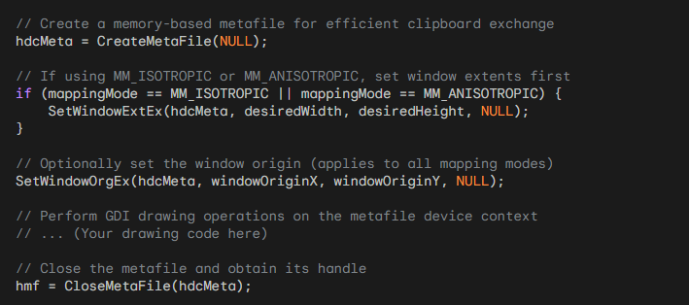

Explanation:

* CreateMetaFile(NULL) generates a memory-based metafile, suitable for clipboard operations.
* SetWindowExtEx establishes logical coordinates within the metafile for MM_ISOTROPIC and MM_ANISOTROPIC, ensuring proper drawing interpretation.
* SetWindowOrgEx optionally sets the origin of the drawing space for all mapping modes.
* GDI drawing calls are performed on the metafile's device context (hdcMeta), recording drawing commands.
* CloseMetaFile finalizes the metafile and returns its handle (hmf).

Preparing the METAFILEPICT Structure:

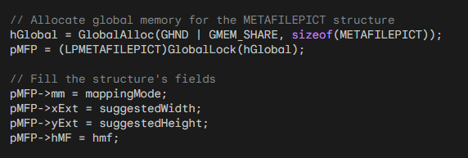

Explanation:

* GlobalAlloc reserves memory accessible to other processes for clipboard exchange.
* GlobalLock obtains a pointer to the allocated memory.
* The METAFILEPICT structure is populated with:
* mm: The mapping mode used within the metafile.
* xExt: Suggested width (interpreted based on mapping mode).
* yExt: Suggested height (interpreted based on mapping mode).
* hMF: The handle to the created metafile.

Copying to Clipboard:

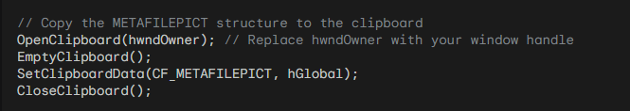

Explanation:

* OpenClipboard grants clipboard access.
* EmptyClipboard clears previous clipboard contents.
* SetClipboardData places the METAFILEPICT structure (and its associated metafile) on the clipboard.
* CloseClipboard releases clipboard access.

Additional Considerations:

Error Handling: Implement robust error checking for functions like CreateMetaFile, GlobalAlloc, and clipboard operations to ensure program stability.

Compatibility: Be mindful of potential compatibility issues when working with older metafile formats and clipboard operations.

Alternative Formats: Consider Enhanced Metafiles (EMFs) for more complex scenarios and broader compatibility.

Retrieving the Metafile from the Clipboard:

Open the Clipboard: Access clipboard contents using OpenClipboard.

Retrieve METAFILEPICT Structure: Obtain a pointer to the METAFILEPICT structure using GetClipboardData(CF_METAFILEPICT).

Extract Information: Extract the following information from the structure:

* mm: The mapping mode used within the metafile.
* xExt: Suggested width (interpreted based on mapping mode).
* yExt: Suggested height (interpreted based on mapping mode).
* hMF: The handle to the metafile itself.

Playing the Metafile:

1.

Set Mapping Mode:

To set the appropriate mapping mode based on the mm value retrieved from the METAFILEPICT structure, you can use the SetMapMode function.

The mm value represents the desired mapping mode, such as MM_TEXT, MM_LOMETRIC, MM_HIMETRIC, MM_LOENGLISH, MM_HIENGLISH, MM_TWIPS, MM_ISOTROPIC, or MM_ANISOTROPIC.

By calling SetMapMode with the appropriate mapping mode value, you can configure the device context for the desired coordinate system and scaling.

2.

Handle Size and Viewport Extents:

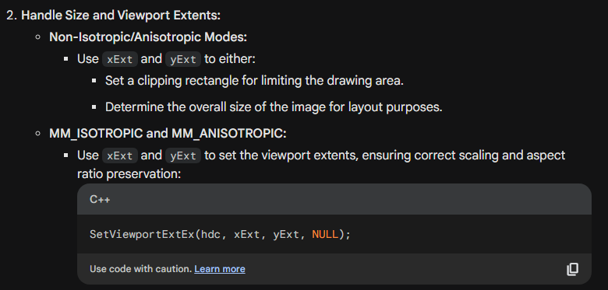

When working with non-isotropic or anisotropic mapping modes, the xExt and yExt values from the METAFILEPICT structure can be utilized in different ways:

* Clipping Rectangle: You can use the xExt and yExt values to define a clipping rectangle that limits the drawing area within the metafile. By setting the clipping region using the coordinates (0, 0, xExt, yExt), you can ensure that any drawing operations stay within the specified bounds.
* Image Size and Layout: Alternatively, the xExt and yExt values can be used to determine the overall size of the image contained in the metafile. This information can be useful for layout purposes, allowing you to position and align the metafile image correctly within your application's interface.

By leveraging the xExt and yExt values, you can adapt the drawing environment to the specific requirements of the metafile, ensuring proper mapping and handling of its contents. This flexibility enables you to create accurate and visually appealing representations of the metafile when playing it back or incorporating it into your application.

3.

Play the Metafile:

Use PlayMetaFile to execute the drawing commands stored within the metafile:



4.

Release Resources:

To properly release resources related to the metafile and clipboard, you can follow these steps:

Close Metafile: After you have finished working with the metafile, it is important to finalize it by calling the CloseMetaFile function. This action ensures that any pending operations or modifications to the metafile are completed and that the resources associated with it are properly released.

Close Clipboard: Once you have finished using the clipboard to copy or paste the metafile, it is essential to release access to the clipboard by calling the CloseClipboard function. This action ensures that other programs can access and modify the clipboard contents as needed.

Key Considerations:

* Recipient Control: The recipient program has flexibility in interpreting xExt and yExt to adjust scaling and viewport behavior based on its display capabilities and visual preferences.
* Mapping Mode Impact: The chosen mapping mode significantly affects how logical coordinates in the metafile map to device coordinates on the screen, influencing the final rendering.
* Error Handling: Incorporate robust error checking for clipboard and metafile operations to safeguard program stability.
* Compatibility: Be mindful of potential compatibility issues, especially when working with older metafile formats or across different platforms.

Retrieving the Metafile:

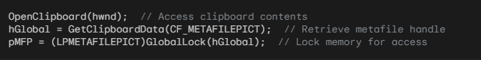

Preparing the Device Context:



Handling Size and Viewport Based on Mapping Mode:

Non-Isotropic/Anisotropic Modes:

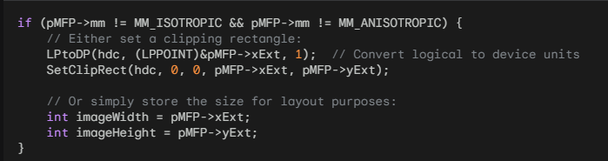

MM_ISOTROPIC and MM_ANISOTROPIC Modes:

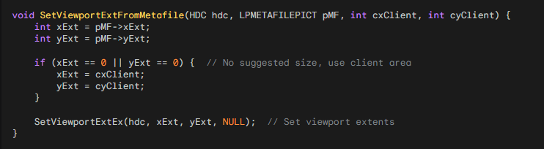

Playing the Metafile:



Releasing Resources:

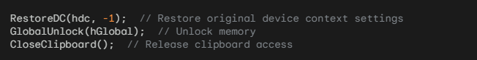

Key Points:

Mapping Mode Significance: The chosen mapping mode dictates how logical coordinates in the metafile map to device coordinates on the screen, significantly impacting rendering.

Recipient Flexibility: Recipient programs can adapt scaling and viewport behavior based on display capabilities and visual preferences.

Units Conversion: LPtoDP is crucial for converting logical coordinates to device units when setting clipping rectangles or interpreting dimensions.

Error Handling: Incorporate error checking for clipboard and metafile operations to ensure program stability.

Compatibility: Be mindful of potential issues when working with older metafile formats or across different platforms.

Retrieving the Metafile from the Clipboard:

OpenClipboard(hwnd): Accesses the clipboard's contents.

hGlobal = GetClipboardData(CF_METAFILEPICT): Retrieves the handle to the METAFILEPICT structure, which holds information about the metafile.

pMFP = (LPMETAFILEPICT)GlobalLock(hGlobal): Locks the memory block associated with the structure to enable access to its data.

Preparing the Device Context for Playback:

SaveDC(hdc): Saves the current device context's settings, ensuring they can be restored later.

SetMapMode(pMFP->mm): Sets the mapping mode of the device context to match the mapping mode used within the metafile. This is crucial for accurate rendering.

Handling Size and Viewport Based on Mapping Mode:

Non-Isotropic/Anisotropic Modes (MM_TEXT, MM_LOMETRIC, MM_HIMETRIC, MM_TWIPS):

Setting a Clipping Rectangle:

LPtoDP(hdc, (LPPOINT)&pMFP->xExt, 1);: Converts xExt and yExt from logical units to device units, ensuring proper scaling and alignment of the clipping rectangle.

SetClipRect(hdc, 0, 0, pMFP->xExt, pMFP->yExt);: Establishes the clipping rectangle to confine the metafile's drawing to the specified area.

Storing Size for Layout:

Retrieves xExt and yExt to determine the overall size of the image for layout purposes within your application.

MM_ISOTROPIC and MM_ANISOTROPIC Modes:

SetViewportExtFromMetafile Function:

Responsible for determining appropriate viewport extents based on the metafile's suggestions and available client area:

If xExt or yExt is zero, it defaults to using the client area's dimensions for viewport extents.

Otherwise, it employs the provided xExt and yExt values.

SetViewportExtEx(hdc, xExt, yExt, NULL);: Sets the viewport extents, controlling how logical coordinates in the metafile map to device coordinates on the screen.

Playing the Metafile:

PlayMetaFile(hdc, pMFP->hMF): Executes the drawing commands stored within the metafile, rendering the image onto the device context.

Releasing Resources:

RestoreDC(hdc, -1): Restores the original device context settings, ensuring subsequent drawing operations are unaffected.

GlobalUnlock(hGlobal): Unlocks the memory block associated with the METAFILEPICT structure.

CloseClipboard(): Releases clipboard access, allowing other programs to interact with it.

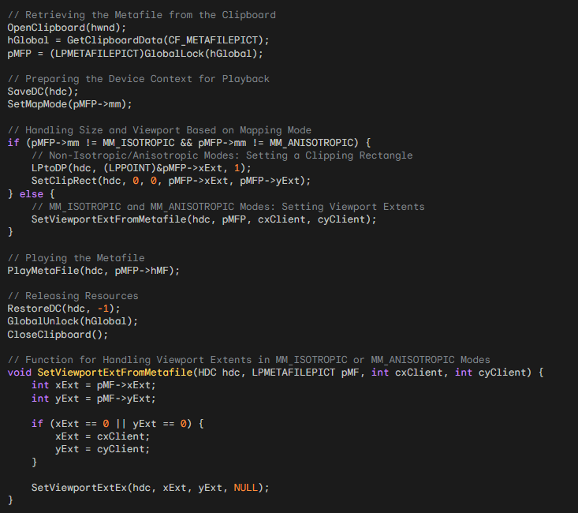

Key Points:

The mapping mode plays a pivotal role in determining how logical coordinates in the metafile translate to device coordinates on the screen, significantly impacting visual output.

Recipient programs have flexibility in adapting scaling and viewport behavior based on their display capabilities and desired visual outcomes.

LPtoDP is crucial for appropriate units conversion when working with logical coordinates.

Always incorporate error handling for clipboard and metafile operations to safeguard program stability.

Be mindful of potential compatibility issues, especially with older metafile formats or across different platforms.

UNDERSTANDING PREPAREMETAFILE:

Central Role: This function meticulously prepares a device context for flawless metafile playback, ensuring faithful visual representation by addressing scaling and aspect ratio concerns.

Mapping Mode Harmony: It initiates its task by establishing alignment between the device context's mapping mode and the metafile's mapping mode. This synchronization is paramount, as mapping modes dictate how logical coordinates within the metafile transform into device coordinates on the screen, profoundly influencing rendering.

Addressing Isotropic and Anisotropic Modes:

Flexibility Focus: The function devotes particular attention to MM_ISOTROPIC and MM_ANISOTROPIC modes, as they grant enhanced control over scaling and aspect ratio preservation. This adaptability proves invaluable for metafiles necessitating precise visual consistency across diverse display environments.

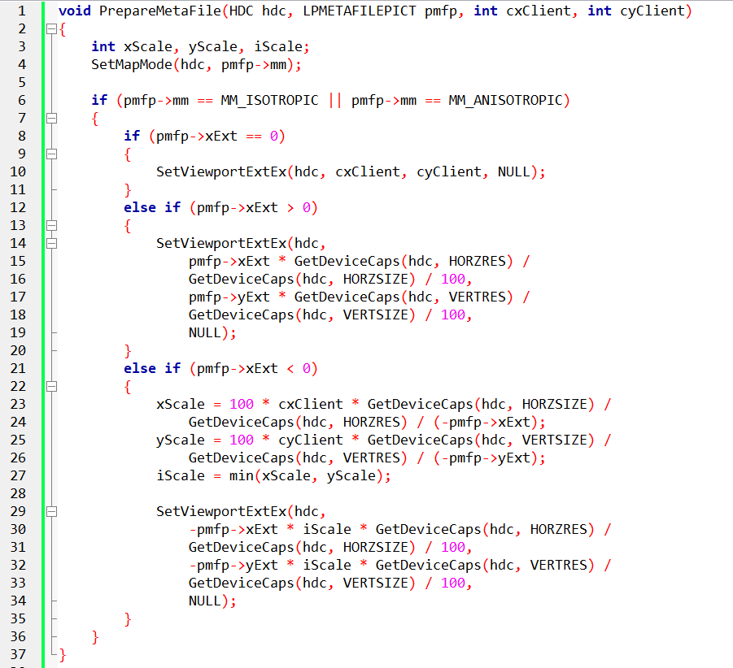

Interpreting Extent Values:

Three-Pronged Approach: The function carefully examines the extent values (xExt and yExt) within the metafile to determine appropriate viewport extents.

No Size or Aspect Ratio Guidance: If xExt is 0, it means there are no suggested dimensions. The function adjusts the viewport extents to match the dimensions of the provided client area, ensuring seamless integration with the surrounding content.

Explicit Size Recommendation: When xExt is greater than 0, it indicates a suggested image size specified in 0.01mm units. The function uses the GetDeviceCaps function to determine the screen's resolution and pixel density. It then calculates the viewport extents that align with the intended dimensions of the metafile.

Aspect Ratio Preservation Priority: In cases where xExt is less than 0, the metafile prioritizes maintaining the aspect ratio while deferring the determination of the size. The function calculates scaling factors (xScale and yScale) that ensure the desired aspect ratio is preserved, resulting in proportional rendering. It then establishes the viewport extents using these scaling factors and the negative extent values, guaranteeing both accurate scaling and aspect ratio fidelity.

Additional Considerations:

Device Capabilities Awareness: The function's use of GetDeviceCaps demonstrates its ability to adapt to different display environments. It can gracefully handle varying screen resolutions and pixel densities, ensuring consistent results across different systems.

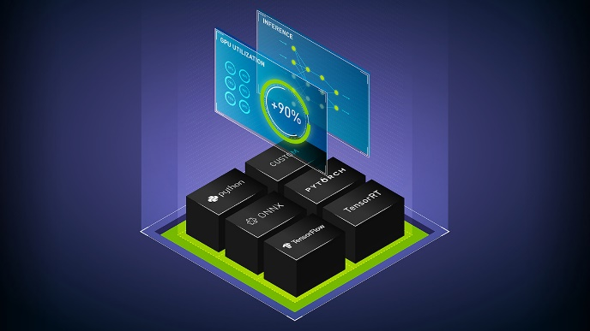

Dual-Purpose Flexibility: The code is designed to handle both suggested size and aspect ratio scenarios, making it versatile enough to accommodate metafiles with different requirements. It can adjust the viewport extents accordingly, ensuring the metafile is displayed correctly.

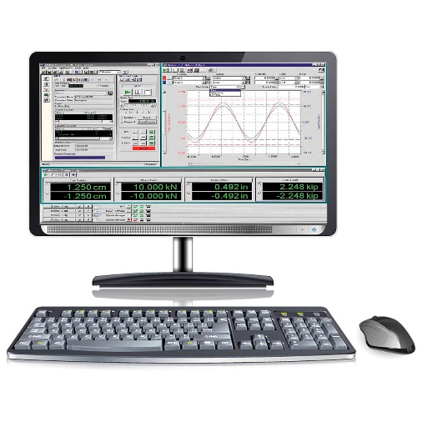

Mapping Mode Impact: The function emphasizes the importance of synchronizing the mapping mode to achieve the desired visual results. Understanding mapping modes is crucial for controlling how the metafile content is rendered.



Error Handling Imperative: Although not explicitly shown in the provided code, it is essential to implement robust error-checking mechanisms for clipboard and metafile operations. Error handling ensures program stability and resilience by handling potential issues that may arise during these operations.

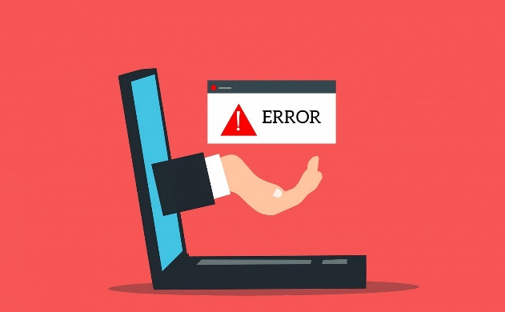

Compatibility Vigilance: Developers should be cautious about potential compatibility challenges when working with older metafile formats or across different platforms. Thorough testing and adherence to format specifications are key to ensuring successful usage of metafiles across multiple platforms.

 

Executing the Metafile:

Optional Viewport Origin: After careful preparation, you have the option to set a specific viewport origin using SetViewportOrgEx. This allows you to control where the image will be positioned within the client area, enabling precise placement.

Metafile Playback: The important PlayMetaFile function takes the spotlight, executing the drawing commands that were recorded in the metafile. It draws the image onto the prepared device context, bringing it to life visually.

Restoring Device Context: Once the metafile has been displayed on the screen, RestoreDC gracefully reverts the device context back to its original state. This ensures that subsequent drawing operations are not affected by the specific settings of the metafile, preserving the integrity of the context.

Releasing Resources:

Memory Unlock: The GlobalUnlock function releases the lock on the memory block that held the metafile data. This allows other programs to access and use that memory region, ensuring efficient utilization of system resources.

Clipboard Closure: The final step involves calling CloseClipboard. This closes the clipboard, allowing other applications to access and interact with its contents. By responsibly releasing the clipboard, resources can be shared harmoniously among different applications.

Enhanced Metafile Considerations:

Effortless Conversion: Windows takes on the responsibility of converting between different metafile formats, such as older formats and enhanced formats. This conversion happens automatically, without requiring manual intervention. It simplifies workflows and promotes compatibility by seamlessly handling the format conversion.

Automatic Translation: When an application places a metafile format on the clipboard, Windows actively translates it into the format requested by the receiving application. This ensures that the data exchange between applications is smooth and avoids any format mismatches.

Viewport Origin Control: Developers can precisely position metafile rendering by strategically adjusting the viewport origin.

Enhanced Metafile Convenience: Windows gracefully handles format conversions for enhanced metafiles, streamlining development efforts.

Resource Management: Releasing memory and closing the clipboard are paramount for responsible resource utilization and system harmony.

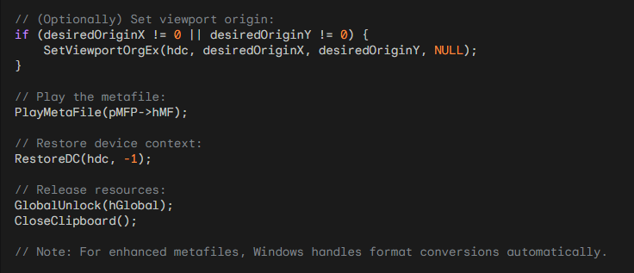

Key Takeaways:

* Viewport Origin Control: Developers have the ability to precisely position the rendering of metafiles by adjusting the viewport origin as needed.
* Enhanced Metafile Convenience: Windows simplifies development efforts by handling format conversions for enhanced metafiles automatically, saving developers from the manual conversion process.
* Resource Management: Releasing memory and closing the clipboard are important steps for responsible use of system resources and ensuring smooth operation between different applications.

METAFILES: KEY ADVANCEMENTS(EMF)

32-bit Introduction: Enhanced metafiles (EMFs) emerged in 32-bit Windows environments to address limitations of their predecessors, Windows metafiles (WMFs).

Functionality Expansion: They offer a suite of new functions, data structures, a distinct clipboard format (CF_ENHMETAFILE), and the .EMF file extension.

Header Enhancements: EMFs boast a significantly enriched header that stores a wealth of information, including:

* Device context settings
* Image dimensions
* Size of embedded objects
* Color management data
* Thumbnail preview
* Application-specific data

Playback Optimization: This wealth of header information empowers applications to tailor playback strategies for optimal rendering, ensuring accurate and efficient display.

Compatibility Considerations:

Format Translation: Windows provides functions for converting between EMF and WMF formats, enabling compatibility with older applications. However, conversions might not always be seamless, as WMF lacks support for certain advanced features introduced in EMF.

Basic Procedure:

Metafile Creation: Employ CreateEnhMetaFile to initiate a new enhanced metafile, specifying a device context and optional filename.

Drawing Operations: Execute standard drawing commands within the metafile context, meticulously recording them for later playback.

Metafile Closure: Call CloseEnhMetaFile to finalize the metafile, sealing its contents and returning a handle for subsequent interaction.

Playback: Utilize PlayEnhMetaFile to render the captured drawing commands onto a device context, bringing the image to life.

Advantages of Enhanced Metafiles:

Advanced Graphics Support: EMFs gracefully accommodate a broader spectrum of graphics features, including paths, regions, and enhanced text handling.



Scalability: They excel in preserving image quality across diverse display resolutions and output devices.



Compactness: EMFs often boast smaller file sizes compared to WMFs, conserving storage space.

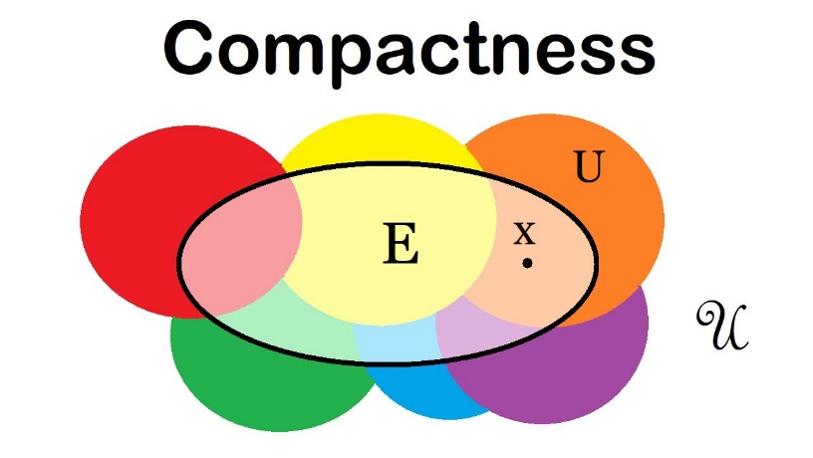

Extensibility: Their extensible structure invites application-specific data inclusion, fostering customization and flexibility.



*Stay tuned for code examples to illustrate these concepts in action!*

EMF1.C PROGRAM

Window Class Registration (WinMain):

Clarity and Efficiency: The program carefully registers a window class named "EMF1" with specific attributes and behaviors. This registration process allows smooth interaction with the Windows operating system, serving as the foundation for creating and handling windows and messages.

Default Values: By using macros like CW_USEDEFAULT and NULL for window size and positioning, the program follows a common practice of accepting default values provided by the system. This approach often simplifies development and ensures compatibility with various screen resolutions.

Message Loop (WinMain):

Responsiveness Cornerstone: The message loop serves as the central component of any Windows application. It continuously listens for and responds to various events, including user input, window resizing, and system notifications. This perpetual cycle ensures that the program remains responsive and adaptable to changing conditions.

Enhanced Metafile Creation (WndProc, WM_CREATE):

Device Context Canvas: The CreateEnhMetaFile function creates a special canvas designed to capture and store graphics commands. This device context serves as the foundation for drawing visual elements within the enhanced metafile.

Drawing Commands: The program uses functions like Rectangle, MoveToEx, and LineTo to skillfully draw a rectangle and two diagonal lines within the metafile. These basic drawing commands are the essential tools for creating visual elements in Windows programming.

Preserving the Masterpiece: CloseEnhMetaFile securely saves the metafile's contents and provides a handle that allows access to the captured artwork. This handle acts as a key, enabling future playback and manipulation of the metafile's visual elements.

Metafile Playback (WndProc, WM_PAINT):

Painting Canvas: The BeginPaint function provides the program with access to a brush that is ready for painting within the window's client area. This brush is applied to a canvas known as the device context, which eagerly awaits the strokes of visual expression.

Focused Display: The program intentionally limits the playback area to the central region of the window, ensuring that the visual experience is concentrated and focused. This attention to detail demonstrates the ability to position and scale metafile content within a window.

Reawakening the Art: PlayEnhMetaFile takes the spotlight, skillfully replaying the recorded drawing commands onto the device context. This process brings the rectangle and lines to life on the window's canvas, showcasing the enduring capability of metafiles to preserve and reproduce visual elements.

Resource Conservation (WndProc, WM_DESTROY):

Return to the Void: The program responsibly frees up the resources associated with the metafile using DeleteEnhMetaFile. This ensures proper memory management and a clean exit from the program. Cleaning up resources is crucial for maintaining system performance and preventing memory leaks.

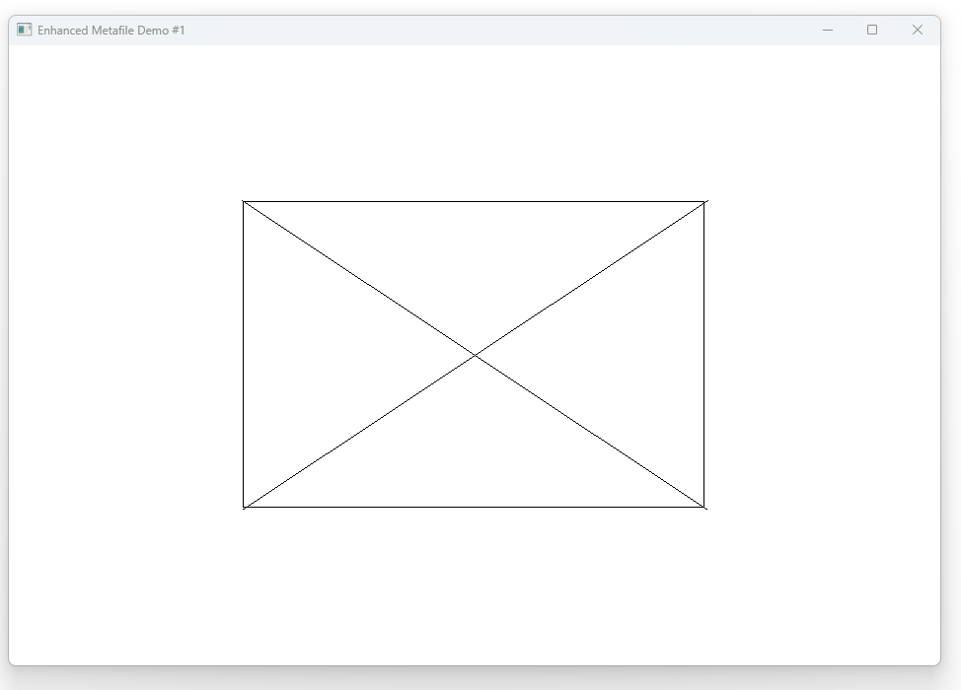

Metafile Creation (WM_CREATE):

Initiation: The CreateEnhMetaFile function begins the creation of the metafile, acting like a magical brush. While the arguments are currently set to NULL, they can be customized for more advanced usage later.

Canvas for Drawing: The CreateEnhMetaFile function returns a special device context handle that serves as a dedicated canvas for drawing within the metafile.

Capturing Artistry: The program skillfully draws a rectangle and two diagonal lines on this special canvas. These drawings are then translated into binary form and stored within the metafile, preserving the visual expression.

Sealing the Masterpiece: CloseEnhMetaFile securely finalizes the metafile's contents, providing a valuable handle that allows access to the captured artistry. This handle acts as a key to unlock and explore the metafile's contents in the future.

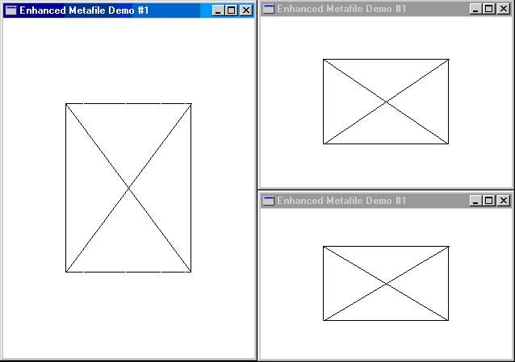

Metafile Playback (WM_PAINT):

Window Dimensions: The program carefully determines the size of its client window using a RECT structure, which is similar to an architect's blueprint.

Centered Focus: The program adjusts the blueprint to create a rectangle that occupies the central area of the window, ensuring a focused viewing experience.

Reawakening Beauty: PlayEnhMetaFile takes the spotlight, skillfully replaying the recorded drawing commands onto the window's device context. This process brings the rectangle and lines to life, demonstrating the enduring ability of metafiles to preserve and reproduce visual elements.

Stretching for Perfection: GDI (Graphics Device Interface), the master of graphics, gracefully stretches the image to fit perfectly within the designated rectangle. This ensures a seamless visual presentation and allows metafiles to adapt and maintain their integrity on various canvases.

Beyond the Basics:

* Pathway to Complexity: This program introduces basic concepts of EMF (Enhanced Metafile Format), laying the foundation for exploring more advanced features like gradient fills, transparency, and image embedding. These capabilities provide a wide range of possibilities for creating visually impressive and interactive graphics experiences.
* Cross-Platform Considerations: Although EMFs are well-suited for Windows, it's important to note that other platforms have their own alternative metafile formats, such as SVG (Scalable Vector Graphics). Understanding these differences is essential for designing graphics that can seamlessly work across different platforms.
* Metafiles as Recorders: Enhanced metafiles efficiently record drawing commands and store them as binary data, allowing for playback at a later time.
* Flexible Display: Metafiles can be displayed within specified rectangles, adjusting their proportions to fit different canvases and maintaining their visual integrity.
* GDI's Role: The Graphics Device Interface (GDI) plays a crucial role in both the creation and playback of metafiles. It ensures that the visual elements are harmoniously rendered and provides the necessary functionality for working with metafiles.